FoodRescue Connect: Smart Food Donation and Redistribution Management System

Code Review & Repository Evaluation

Submitted partial fulfilment for the Course of

CSA1012 Software Engineering
to receive the award of the degree of
ARTIFICIAL INTELLIGENCE AND MACHINE LEARNING

Submitted by Ramana Y (192525476)

Under the Supervision of ANITADAVAMANI K



SIMATS ENGINEERING
Saveetha Institute of Medical and Technical Sciences Chennai-602105
August-2026

PROBLEM OVERVIEW AND REPOSITORY ORGANIZATION
1. Problem Overview
Food waste is a common problem where large amounts of usable food are thrown away while many people still need access to food. Restaurants, supermarkets, hotels, event organizers, and food manufacturers may have surplus food, but the lack of proper coordination can make collection and redistribution difficult.
FoodRescue Connect is designed as a centralized platform that connects food donors with NGOs, volunteers, and beneficiaries. The system allows available food to be listed, requested, collected, and delivered in a more organized way.
The proposed solution also uses technologies such as Artificial Intelligence, IoT, GPS, cloud computing, and real-time notifications. AI can support food allocation and route planning, while IoT can help monitor food-related conditions.
Key Functionalities
The major functionalities include user registration, donation listing, food search, donation requests, volunteer assignment, pickup tracking, delivery management, notifications, AI-based allocation, and reporting.
2. Repository Organization
The project is organized into separate modules so that each part can be maintained without unnecessarily affecting the others.
FoodRescue-Connect/
│
├── frontend/
├── backend/
├── ai-service/
├── iot-service/
├── database/
├── docs/
├── docker/
├── .gitignore
├── README.md
├── Dockerfile
└── docker-compose.yml
The frontend folder contains the user interface, while backend handles APIs and application logic. The ai-service is intended for intelligent processing and iot-service handles sensor-related communication. The database folder contains database-related files, while docs contains project documentation and diagrams.
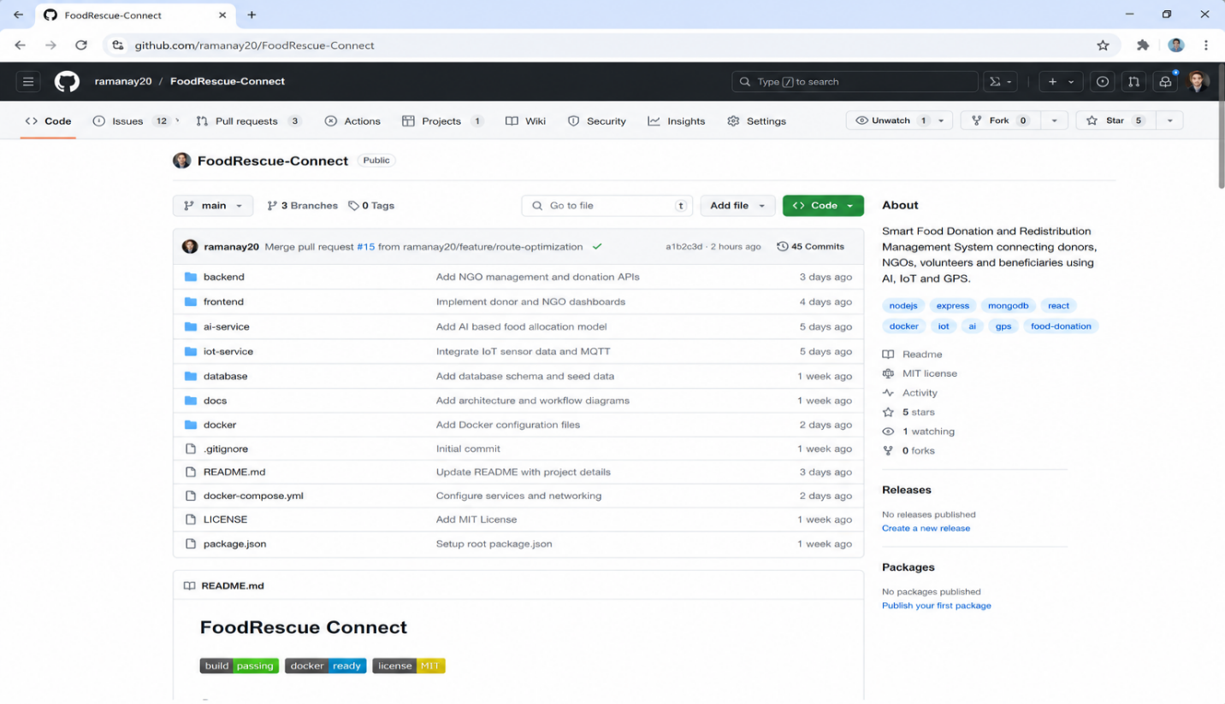
This type of organization makes the project easier to understand and allows developers to work on different modules independently.
Figure 1: FoodRescue Connect GitHub Repository
The GitHub repository screenshot provides visual evidence of the project structure and the main files used in the project.
3. Architecture and Component Design
The system follows a modular architecture in which the frontend communicates with the backend, while the backend connects with the database and supporting services such as AI and IoT.
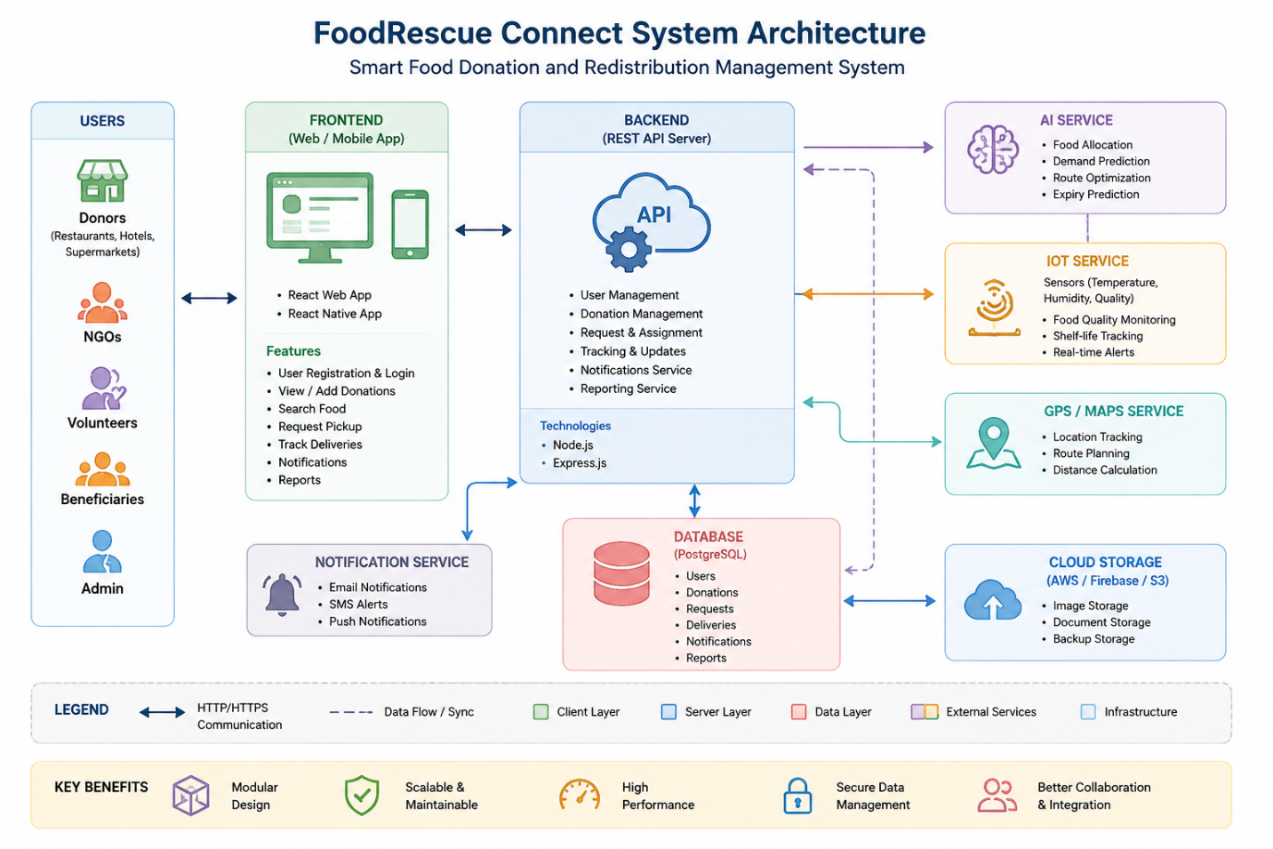Figure 2: FoodRescue Connect System Architecture
The architecture supports maintainability because individual services can be modified or improved without redesigning the complete system.

CODE QUALITY AND VERSION CONTROL REVIEW
4. Code Quality Review
The code review focuses on four main areas: readability, modularity, coding practices, and documentation. These are important because the assessment gives the Code Quality Review the highest individual weight of 25%.
Readability
The project is divided into meaningful modules such as frontend, backend, AI, IoT, and database. Using descriptive folder and file names makes it easier for another developer to understand where a particular feature belongs.
Variable and function names should describe their actual purpose rather than using unclear names such as x, temp1, or data2. Short functions are also easier to understand and test.
Modularity
The project follows a modular approach by separating different responsibilities. For example, user management, donation management, AI processing, and route optimization can be maintained as separate parts of the application.
This reduces unnecessary dependency between modules and makes future changes easier.
Coding Standards
Consistent indentation, naming conventions, meaningful function names, and organized files should be followed throughout the project. Repeated code should be avoided where possible, and common functionality should be placed into reusable functions or services.
Documentation
Comments should be used where they help explain complicated logic rather than explaining every simple line. The README should also provide enough information for another developer to understand and run the project.
Strengths
- Clear separation of major application components.
- Meaningful project modules.
- Suitable structure for future expansion.
- Git-based development supports controlled changes.
- Docker configuration supports consistent deployment.
Areas for Improvement
- Add more detailed comments for complex AI and allocation logic.
- Keep naming conventions consistent across all modules.
- Avoid duplicate code between services.
- Add stronger input validation.
- Improve error handling and user-facing error messages.
- Add automated testing for important backend functions.
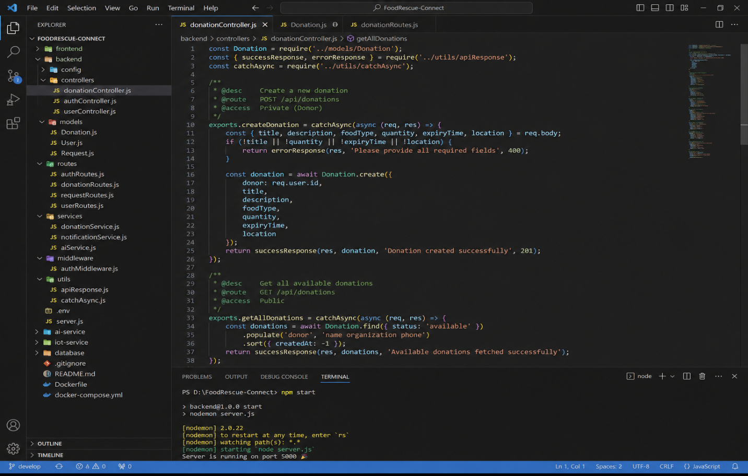Figure 3: FoodRescue Connect Code Review / Source Code
The code screenshot should be used as supporting evidence for readability, modularity, naming conventions, and coding practices.
5. Version Control Evaluation
Git and GitHub are used to maintain the project history. A feature-based branching approach can be used with main, develop, and individual feature branches.
main
│
└── develop
├── feature/user-management
├── feature/donation-management
├── feature/ai-allocation
└── feature/route-optimization
Meaningful commits such as:
- Initial project setup
- Add user authentication
- Add donation management
- Implement AI food allocation
- Add route optimization
- Add Docker configuration
are easier to understand than messages such as update, changes, or final.
Version control supports collaboration because developers can work on separate branches and later merge their completed work.
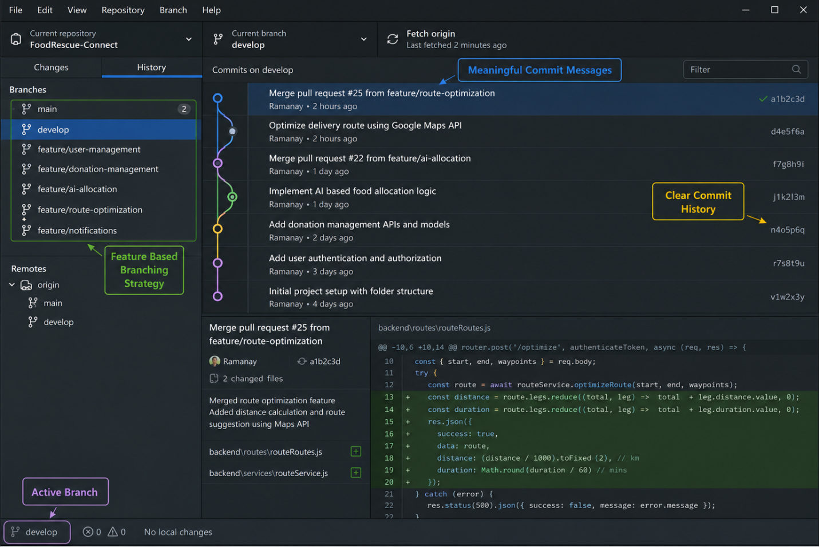Figure 4: Git Branching and Commit History
The Git screenshot supports the evaluation of branching, commits, and repository maintenance.

TESTING, DOCUMENTATION AND RECOMMENDATIONS
6. Code Testing and Validation
Testing is important because the system handles donations, users, pickup requests, and delivery information. The main functions should be tested individually before considering the complete application ready.
Test Case | Expected Result
User registration | User account is created successfully
User login | Valid user is allowed to access the system
Add donation | Donation details are stored successfully
Find donation | Available donations are displayed
Request pickup | Pickup request is recorded
Assign volunteer | Volunteer receives the assigned task
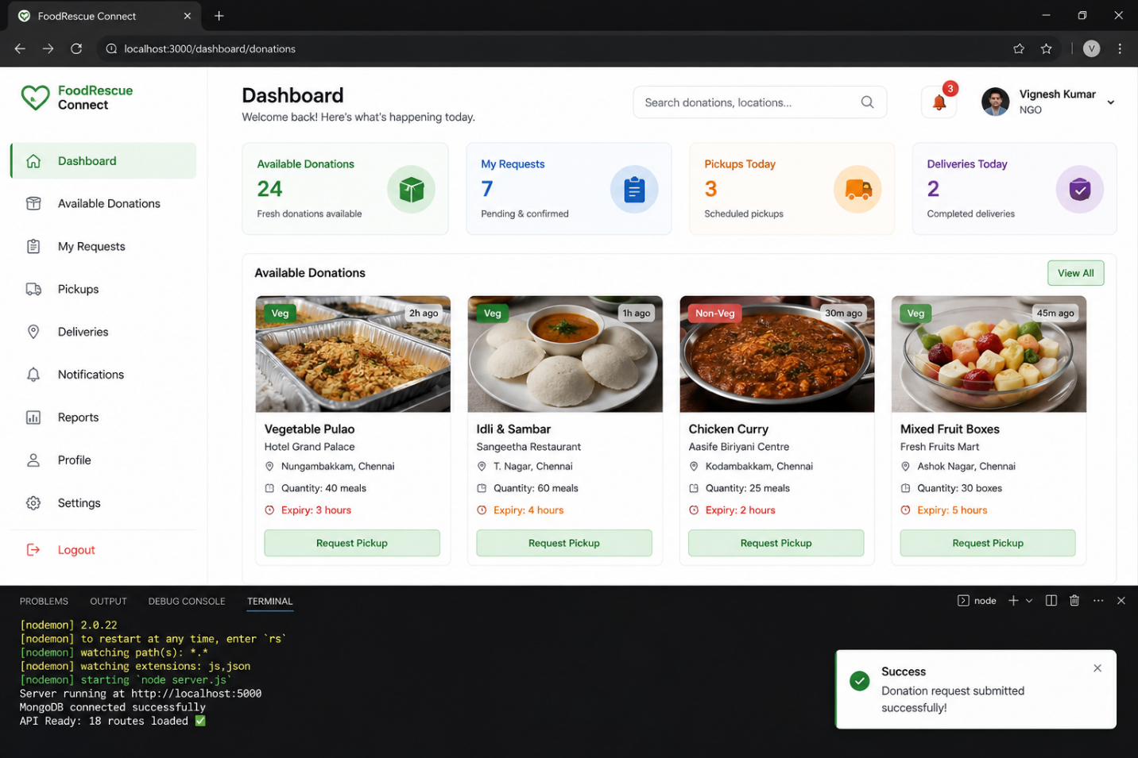Figure 5: FoodRescue Connect Application Testing

The screenshot should show the application running and provide evidence of successful execution.
7. Repository Documentation
The README.md file should give a new developer enough information to understand and run the project.
The documentation should contain:
- Project introduction.
- Main features.
- Technology stack.
- Project structure.
- Installation steps.
- Required dependencies.
- Configuration details.
The current project structure includes a README file, but documentation can be improved by adding clearer setup instructions, example configuration values, API information, and troubleshooting steps.
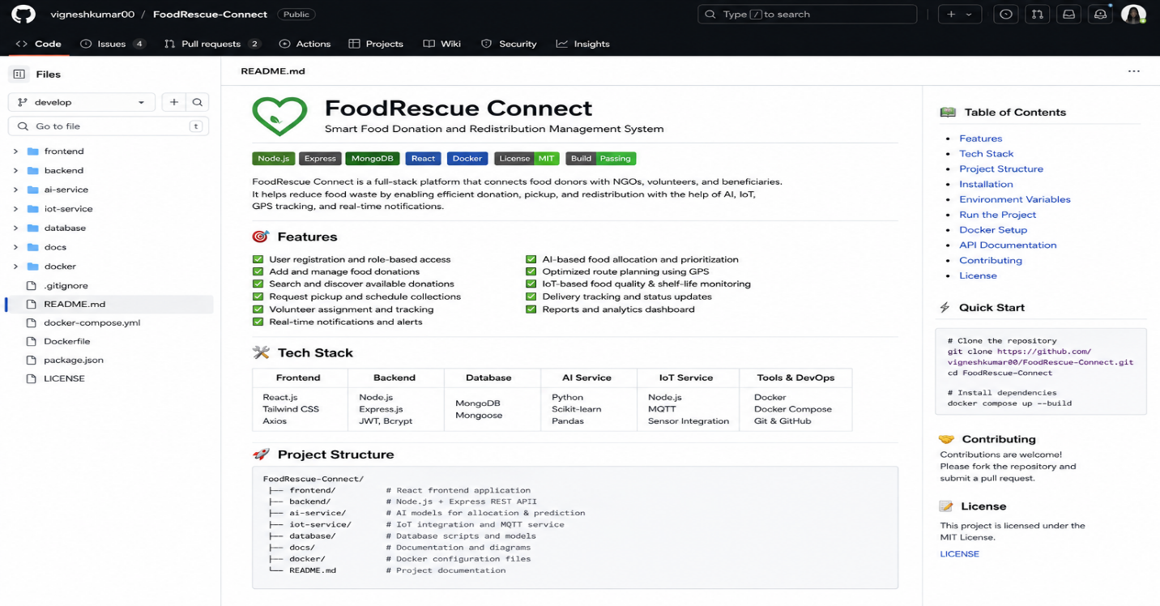Figure 6: FoodRescue Connect README / Documentation
Good documentation reduces the time required for a new developer to understand the project and helps keep the repository maintainable.
8. Review Findings and Recommendations
Overall, FoodRescue Connect has a suitable modular structure for a system involving multiple
services. Separating the frontend, backend, AI, IoT, and database components provides a good starting point for further development.
The main improvements recommended are:
- Add automated unit and integration tests.
- Maintain consistent naming and coding standards.
- Improve error handling and input validation.
- Add detailed API documentation.
- Keep Git commit messages meaningful.
- Protect the main branch from direct unreviewed changes.
- Improve README installation and troubleshooting instructions.
- Add automated CI/CD testing through GitHub Actions.
- Monitor Docker containers during deployment.
- Improve AI testing using different food allocation scenarios.
9. Conclusion
The Code Review and Repository Evaluation shows that FoodRescue Connect has a clear purpose and a modular project structure suitable for further development. The use of Git and GitHub provides a controlled way of managing source-code changes, while the planned Docker environment supports consistent deployment.
The main focus for improvement should be automated testing, stronger documentation, consistent coding practices, and better repository maintenance. With these improvements, the project can become easier to maintain, easier for new developers to understand, and more reliable during future development.

